KINGDOM OF BHUTAN

COMMERCIAL AGRICULTURE AND RESILIENT
LIVELIHOODS ENHANCEMENT PROGRAMME

How to update Online Annual Progress Report
using Google sheet?

Type of Document : Guide
Date : 2016

Online Annual Progress Report using Google sheet
The convention method of annual progress reporting was tedious, time consuming and sometime problematic for both the Programme staffs (especially M&EO) and implementers. The issue of different reporting format was always evident despite of continues effort to maintain uniformity among the implementers.
Therefore, as suggested by Dzongkhags during the first Dzo-CARLEP consultation meeting, Office of the Programme Management (OPM), CARLEP would like to introduce the online reporting system for Annual Progress Report (APR). The main objective of the move is to improve the efficiency and uniformity in reporting format across all implementing agencies. It will also save lot of time for both the implementers and OPM.
CARLEP will be using google sheets for APR. Google Sheets can be shared and edited over the Internet making them ideal for multiple agencies to work on single file. The main advantages of online storage of spreadsheet files include:
- Accessible from any Internet-connected computer
- Allowing the right user to enter data or remove it
- Shared access and editing in real time of online files
- View the progress for other agencies
- Update the progress on time through both online and offline methods.

General Information
- OPM shall be the owner with full access right with M&EO.
- DLO, DAO and respective responsible persons from four regional agencies (ARDC, RLDC, RAMCO, FCBL) shall be the editors.
- Editors shall have right to comment, copy, paste, download, print and add/delete data on/from ‘actual achievement’ column in respective sheets.
- Commenters’ shall have right only to comment and view
- Viewer can only view.

How to update Annual Progress Report online on google sheet?

Mandatory requirement
- A good internet connection
- A chrome browser and google drive apps for offline editing (not mandatory).
- A user must have google account (either private or official).
- A user must ensure that the most active and current email ID is with OPM
- A user must have access to online APR with editor’s right to add data. (OPM shall assign the right of editors, commenters and viewers accordingly.)

For the ease for everyone, let’s start from how to open google sheets and use it to update APR. The following pictorial explanation should be simple enough.

- Open google drive
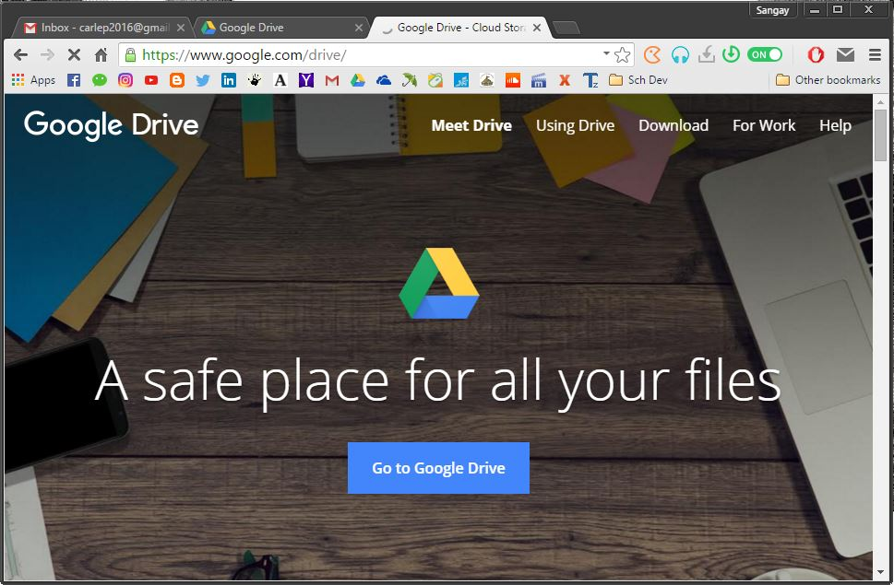
You can either open google drive apps or open drive from your Gmail account directly.

2). Open drive from Gmail directly.
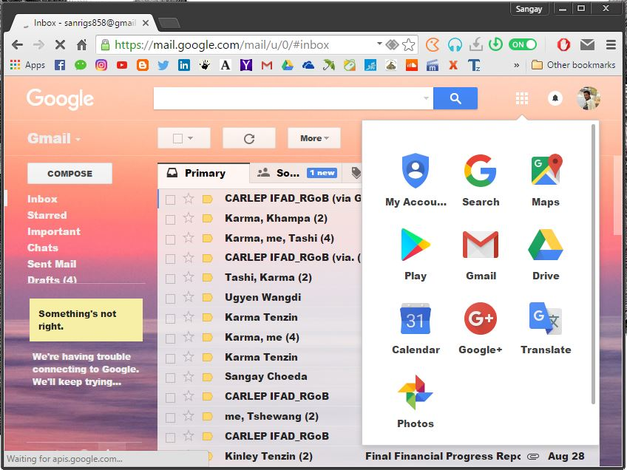
- Click on the google apps icon and select drive.

3). Then, go to ‘Shared with Me’ and open the ‘Final Progress Report’ which is in .xlsx format (google sheet format).
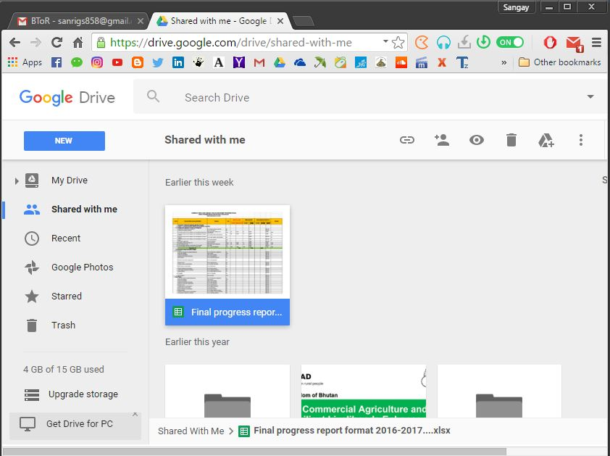

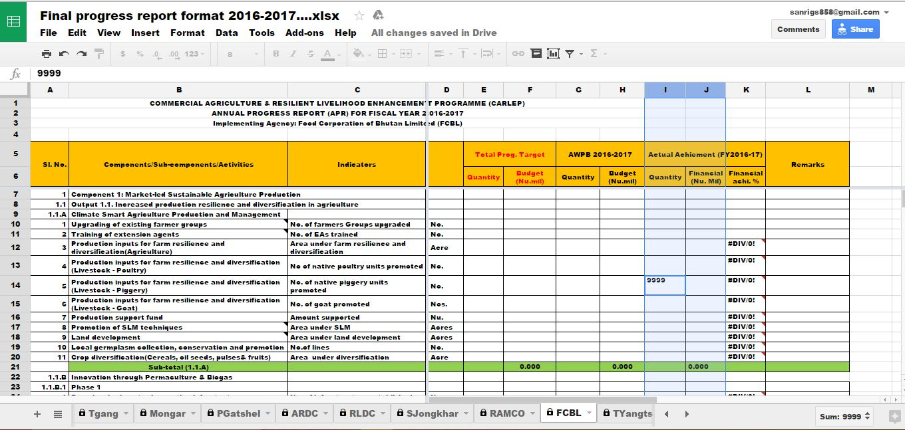
4). This the format for APR. the Editor can now enter their physical and financial achievement data into the respective column and sheet. (No password is required to open the file). For example, FCBL personnel can only enter his data only in FCBL sheet. He/she does not have right to edit on other sheets.

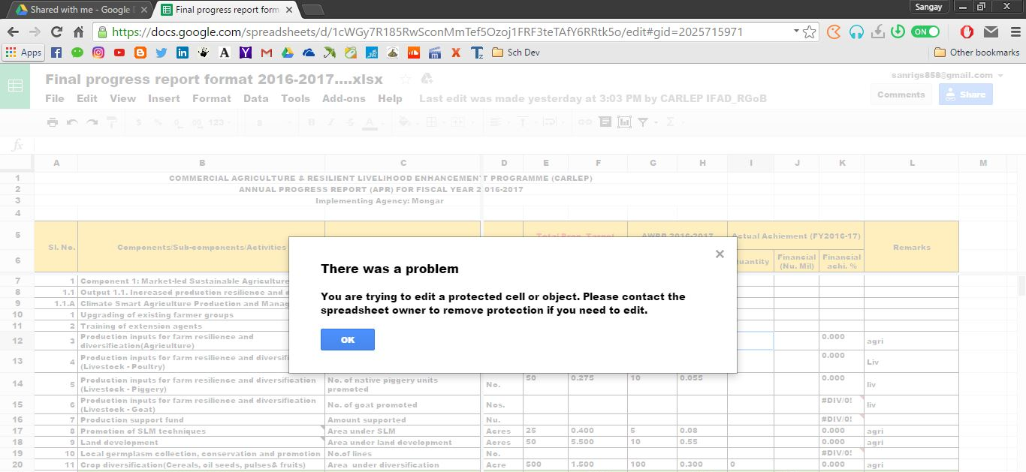
5). Editors cannot edit on other sheet or protected cell. If one do so, problem dialog box will pop-up.

6). After you finish entering data, just close the sheet. It will automatically save and update.
How to update the Annual Progress Report using Google Sheet through offline methods?
Mandatory requirement
- A browser.
- Google drive installed in your PC (Refer instruction below).
- Internet connection at certain interval (not necessary to connect internet to PC while you update the APR, but at least connect your working PC to internet once a week. Or once you have updated on APR, connect your PC to internet after few days.
Instructions
- Download and install Google drive (see instruction on next page).
- Open Google drive on web.
- Go to ‘Share with me’ and right-click on the shared APR file, i.e. ‘Final Annual Progress Report Format 2016-2017.xslx’.
- Select ‘add to my drive’.
- Open offline Google drive folder in your PC. The APR file ‘Final Annual Progress Report Format 2016-2017.xslx’ should be in your drive folder. Now you can open the file whenever required, with/without net connection, and start updating the progress. As soon as you connect your PC to internet, google drive will start synchronizing automatically and the progress shall be updated online.

How to download and install google drive?
Below are the instructions to install Google Drive on your Computer:
- Go to http://drive.google.com.
- Click the Download Google Drive for your PC button.
- Open googledrivesync.exe to automatically install and start Google Drive on your PC. (You may receive a warning that Google Drive is an application downloaded from the Internet. Click the Open button.)
- Enter your Google Account username and password in the window that opens. This will be the account associated with Google Drive for your PC.
- Complete the installation package instructions.
- Launch Google Drive for your PC from the Start menu. Drag files and folders into your Google Drive folder to begin syncing items to My Drive (part of Google Drive on the web).
0r Watch the YouTube tutorial clip at https://www.youtube.com/watch?v=NsKnLVi2z4o (the methods used in the video clip is different from above instruction.)

